  - Baseline Water Quality Study
  - Requestor of Proposed Study
AEA anticipates resource agencies will request this study.
  - Responses to Study Request Criteria (18 CFR 5.9(b))
    - Describe the goals and objectives of the study proposal and the information to be obtained.
The collective goal of the water quality studies is to assess the effects of the proposed project operations on water quality in the Susitna River basin and to identify and develop protection, mitigation, and enhancement measures that can be implemented to minimize these effects.

The objectives of the Baseline Water Quality Study are to:
- Build upon and use, as appropriate, the historical water quality data available for the study area.
- Continued collection of stream temperature and meteorological data.
- Characterize surface water physical, chemical, and bacterial water quality conditions in the Susitna River within and downstream of the proposed project area.
- Document baseline metals concentrations in sediment and fish tissue and compare to state criteria.
- Assess the potential for mercury methylation (i.e., bioavailable form) in the newly formed reservoir and assess the potential for changes to mercury levels in fishes in the proposed reservoir.
- Conduct a pilot thermal imaging assessment of a portion of the Susitna River.
    - If applicable, explain the relevant resource management goals of the agencies and Alaska Native groups with jurisdiction over the resource to be studied.
To be completed by the requesting organization.
    - If the requester is not a resource agency, explain any relevant public interest considerations in regard to the proposed study.
Aquatic resources are owned by the State of Alaska, and the Project could potentially affect these public interest resources by affecting water quality.
    - Describe existing information concerning the subject of the study proposal, and the need for additional information.
Historical water quality data available for the study area includes water temperature data collected during the 1980s. Some of these data will be evaluated as part of the 2012 WQ-S1: Water Temperature Modeling Results and Data Collection study with regard to their applicability to the 2013–2014 water quality studies.
A data gap analysis was conducted for water quality and sediment transport in 2011 (URS 2011). The data gap analyses were used to identify future studies needed to develop the riverine and reservoir water quality models. These are as follows:
Lower Susitna from Cook Inlet to the Susitna – Chulitna –Talkeetna confluence
(River Mile 0-99)
- Large amounts of data were collected in this reach during the 1980s. Very little data are available that describe current water quality conditions.
- Metals data are not available for the mouth of Chulitna River. The influence of major tributaries (Chulitna and Talkeetna Rivers) on water quality conditions is unknown. There are no monitoring stations in receiving water at these mainstem locations.
- Metals data are not available for the Skwentna River or the Yentna River.
- Continuous temperature data are not available for the mainstem and sloughs potentially used for spawning and rearing habitat.
Middle Susitna River and tributaries from the Susitna – Chulitna–Talkeetna confluence to the mouth of Devil’s Canyon
(River Mile 99-150)
- The source(s) for metals detected at high concentrations in mainstem Susitna River are unknown.
- Current data reflects large spatial data gaps between upper river and the mid- to lower portion of the river.
- Continuous temperature data is not available for mainstem, tributary, and sloughs potentially used for spawning and rearing.
Middle Susitna River from Devil’s Canyon to the proposed Susitna-Watana Dam site (River Mile 150-184)
- Temperature data is not available above and below most tributaries on the mainstem Susitna River.
- Overall, very limited surface water data available for this reach.
- Metals monitoring data does not exist or is limited.
- Concentrations of metals in sediment immediately below the proposed project are not known. Metals in these sediments may become mobile once the project begins operation.
- Monitoring of mainstem and sloughs (ambient conditions and metals) is needed for determining the potential for metal bioaccumulation in fishes.
Upper Susitna River including headwaters and tributaries above the proposed Susitna-Watana Dam site
(River Mile 184-313)
- Surface water and sediment analysis for metals are not available for the mainstem, only for one tributary.
- Information on concentrations of metals in media and current water quality conditions is needed to predict if toxics can be released in a reservoir environment.
- Continuous temperature data is not available for mainstem, tributary, and sloughs potentially used for spawning and rearing.
    - Explain any nexus between project operations and effects (direct, indirect, and/or cumulative) on the resource to be studied, and how the study results would inform the development of license requirements.
This study addresses some aspects of the following issues identified in the PAD (AEA 2011) for which existing information appears to be insufficient. The project's operations will modify the flow and water temperature regimes in the Susitna River downstream of the proposed reservoir. Reservoir operation and storage levels will affect water temperature in the reservoir and influence outflow water temperatures. Alteration of the baseline water temperature regime of the Susitna River is expected to modify baseline river ice conditions (which may affect channel morphology and riparian vegetation) and the suitability and productivity of aquatic habitats.
The results of the 2013–2014 water quality studies will be used as a basis to assess the effects of the proposed project operations on water quality in the Susitna River basin and to identify and develop any necessary protection, mitigation, and enhancement measures related to water quality (including temperature), ice formation, and aquatic habitat in the reservoir and in project-affected river reaches downstream of the dam. Water quality sampling will be conducted at sites where data can be shared between Ice Process Studies, Aquatic Resource Studies, and Geomorphology Studies
    - Explain how any proposed study methodology (including any preferred data collection and analysis techniques, or objectively quantified information, and a schedule including appropriate field season(s) and the duration) is consistent with generally accepted practice in the scientific community or, as appropriate, considers relevant tribal values and knowledge.
The study components consist of:
- Water temperature data collection;
- Meteorological (MET) data collection;
- Baseline water quality measurements;
- Sediment and pore water samples for mercury/metals in reservoir area;
- Fish tissue samples; and
- Evaluation of a pilot thermal imaging effort for identification of thermal refugia

Water temperature data and MET data will be imitated in 2012 and carried through to 2013/2014.

      - Water Temperature Data Collection
Overview
Water temperature data loggers will be installed at 39 sites identified in Table 1 and Figure 1 as part of the 2012 Study Plan. These sites were selected based on
- Results of the 1980s studies;
- Adequate representation of locations throughout the Susitna River and tributaries above and below the proposed dam site;
- Preliminary consultation with AEA and licensing participants including co-location with other study sites (e.g., instream flow, ice processes); and
- Access and land ownership issues.
- Eight of the sites are mainstem monitoring sites that were previously used for SNTEMP modeling in the 1980s. Thirty-one of the sites are mainstem, tributary, or slough locations, most of which were also monitored in the 1980s.
Monitoring Protocol
Water temperatures will be recorded in 15-minute intervals using Onset TidbiT v2 water temperature data loggers (or equivalent instrumentation). The TidbiT v2 (or equivalent) has a precision sensor for ±0.2°C accuracy over an operational range of -20° to 70°C (-4° to 158°F).Data readout is available in less than 30 seconds via an Optic USB interface
Table 1. Proposed Susitna River Basin Temperature and Water Quality Monitoring Sites
Susitna River Mile | Description | Susitna River Slough ID | Latitude  (decimal degrees) | Longitude  (decimal degrees)
10.1 | Susitna above Alexander Creek | NA | 61.4014 | -150.519
25.8³ | Susitna Station | NA | 61.5454 | -150.516
28.0 | Yentna River | NA | 61.589 | -150.468
29.5 | Susitna above Yentna | NA | 61.5752 | -150.248
40.6³ | Deshka River | NA | 61.7098 | -150.324
55.0¹ | Susitna | NA | 61.8589 | -150.18
83.8³ | Susitna at Parks Highway East | NA | 62.175 | -150.174
83.9³ | Susitna at Parks Highway West | NA | 62.1765 | -150.177
97.0 | LRX 1 | NA | 62.3223 | -150.127
97.2 | Talkeetna River | NA | 62.3418 | -150.106
98.5 | Chulitna River | NA | 62.5574 | -150.236
103.0^{2,3} | Talkeetna | NA | 62.3943 | -150.134
113.0² | LRX 18 | NA | 62.5243 | -150.112
120.7^{2,3} | Curry Fishwheel Camp | NA | 62.6178 | -150.012
126.0 | -- | 8A | 62.6707 | -149.903
126.1² | LRX 29 | NA | 62.6718 | -149.902
129.2³ | -- | 9 | 62.7022 | -149.843
130.8² | LRX 35 | NA | 62.714 | -149.81
135.3 | -- | 11 | 62.7555 | -149.7111
136.5 | Susitna near Gold Creek | NA | 62.7672 | -149.694
136.8³ | Gold Creek | NA | 62.7676 | -149.691
138.0¹ | -- | 16B | 62.7812 | -149.674
138.6³ | Indian River | NA | 62.8009 | -149.664
138.7² | Susitna above Indian River | NA | 62.7857 | -149.651
140.0 | -- | 19 | 62.7929 | -149.615
140.1² | LRX 53 | NA | 62.7948 | -149.613
142.0 | -- | 21 | 62.8163 | -149.576
148.0 | Susitna below Portage Creek | NA | 62.8316 | -149.406
148.8² | Susitna above Portage Creek | NA | 62.8286 | -149.379
148.8 | Portage Creek | NA | 62.8317 | -149.379
148.8³ | Susitna above Portage Creek | NA | 62.8279 | -149.377
165.0¹ | Susitna | NA | 62.7899 | -148.997
180.3¹ | Susitna below Tsusena Creek | NA | 62.8157 | -148.652
181.3³ | Tsusena Creek | NA | 62.8224 | -148.613
184.5¹ | Susitna at Watana Dam site | NA | 62.8226 | -148.533
194.1 | Watana Creek | NA | 62.8296 | -148.259
206.8 | Kosina Creek | NA | 62.7822 | -147.94
223.7³ | Susitna near Cantwell | NA | 62.7052 | 147.538
233.4 | Oshetna Creek | NA | 62.6402 | -147.383
¹ Site not sampled for water quality or temperature in the 1980s or location moved slightly from original location.
² Proposed mainstem Susitna River temperature monitoring sites for purposes of 1980s SNTEMP model evaluation.
³ Locations with overlap of water quality temperature monitoring sites with other studies.
Locations in bold represent both temperature and water quality samples.

Figure 1 Proposed 2012 Stream Water Quality and Temperature Data Collection Sites for the Susitna-Watana Hydroelectric Project.
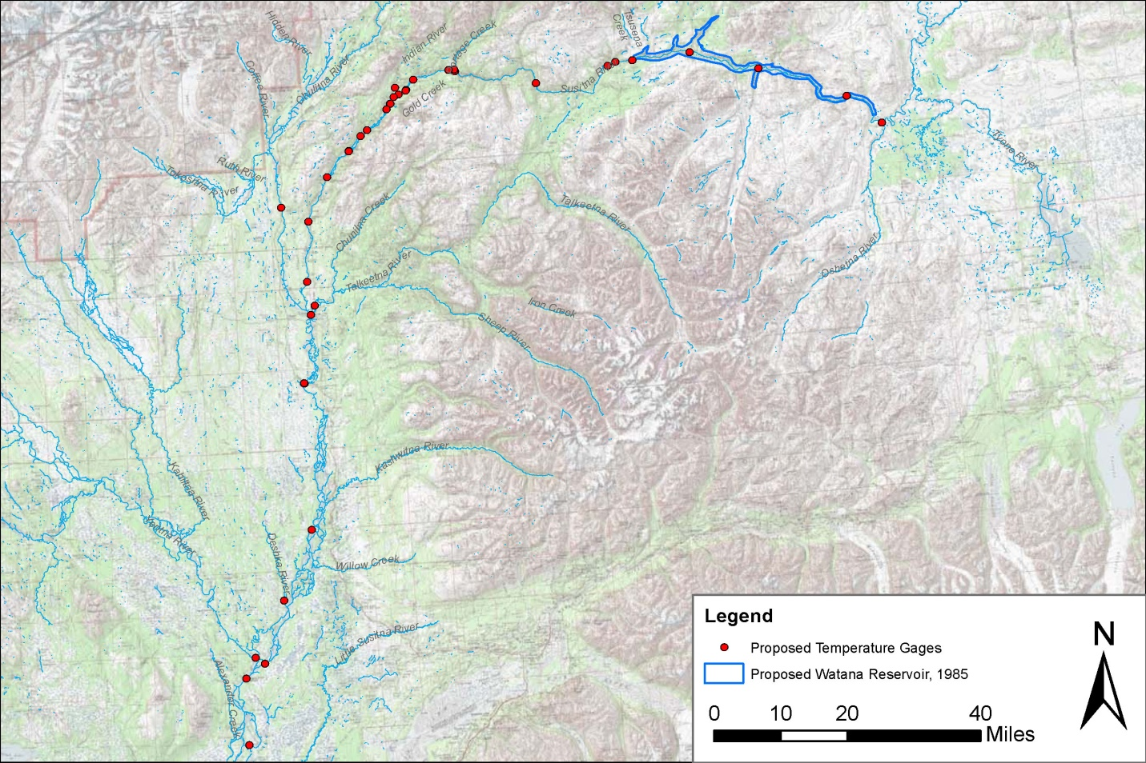

To reduce the possibility of data loss, a redundant data logger will be used at each site. In general, the two sets of sensors will be installed in different fashions (depending on site characteristics). One logger will be inserted into the bottom of a 2.5-meter (8.2-foot) length of perforated steel pipe housing which is fastened to a large bank structure via clamps and rock bolts. The TidbiT® (or equivalent instrument) will be attached to a rope which allows it to be easily retrieved for downloads. The top pipe cap will contain a locking mechanism which can only be opened using the appropriate Allen key to prevent theft or vandalism. The second set of temperature loggers will be anchored to a concrete block and buoyed so that a bottom, mid, and surface logger record continuous temperature conditions throughout the water column (fewer temperature loggers may be deployed depending on site characteristics). The block will be placed in a location of the channel that is accessible and retrievable during routine site visits and the apparatus will be attached with a steel cable to a post which is driven into the bank or to some other structure. The proposed installation procedures may require some alteration based on site specific conditions.

The sensors will be situated in the river to record water temperatures which are representative of the mainstem or slough being monitored, avoiding areas of groundwater upwelling, unmixed tributary flow, direct sun exposure, and isolated pools that may affect the quality of the data.
The 2012 instream flow study will install water-level loggers with temperature recording capability at several study sites that are yet to be determined. Where these study sites overlap the water temperature monitoring study sites (Figure 1), the water-level logger temperature sensors may be used. A redundant TidbiT v2, however, would be deployed at these sites for backup temperature recording.

      - Meteorological Data Collection
Overview
Meteorological (MET) data collection will be initiated and MET stations will be installed and/or upgraded at up to eight (8) locations during 2012 between RM 224 and RM 25.6. Table 2 lists the MET station locations. The exact spatial location will depend on access and suitability of an appropriate site for installing a MET station.
Table 2. Proposed Susitna-Watana Meteorological Stations
Susitna River Mile | Description | Station Status  (New / Existing) | Latitude  (Decimal degrees) | Longitude  (Decimal degrees)
25.8 | Susitna at Susitna Station | New | 61.545399 | -150.51601
44.3 | Willow Creek | Existing (Talkeetna RWIS) | 61.765 | -150.0503
80.0 | Susitna River near Sunshine Gage | Existing (Talkeetna RWIS) | 62.1381 | -150.1155
95.9 | Susitna River at Talkeetna | Existing (Talkeetna Airport) | 62.32 | -150.095
136.8 | Susitna River at Gold Creek | New | 62.767601 | -149.69099
184.1 | Susitna River at Watana Dam (near river) | New | 62.8240 | -148.5636
184.1 | Susitna River at Watana Dam Camp (upland on bench) | New | 62.8226 | -148.5330
224.0 | Susitna River above Cantwell | New | 62.7052 | -147.53799

The two MET stations near the Watana Dam site need to be established at specific locations as requested by Project design engineers. The upland MET station will record snowfall data and precipitation. The upland MET station will be established at about the 2,300 foot elevation on the north side of the river, in the area of the proposed field camp. The near riversite MET station will be located on the north abutment just above river level depending on suitability of location for establishing the structure.
Existing meteorological stations will be fitted with additional monitoring equipment and expand data collection to meet project needs and to use historical information collected from each of these sites (Table 3). The linkage between historical records and continuing data records may be used in evaluating utility of 1980s temperature data for modeling.
MET Station Parameters
MET stations are required to collect several types of parameters that will be used by the engineering design team for the proposed dam and will be used to provide inputs to the water quality temperature model. The following is a comprehensive list of parameters required for use in this Project and will be measured continuously by each of the MET stations:
- Temperature – max, min, mean
- Relative humidity
- Barometric pressure
- Precipitation
- Wind speed – maximum, minimum, mean
- Wind direction
- Wind gust – maximum
- Wind gust direction
- Solar degree days

Installation and Monitoring Protocol
Each MET station will consist of, at a minimum, a 3-meter tripod with mounted monitoring instrumentation to measure and record wind speed and direction, air temperature, relative humidity, barometric pressure, incident solar radiation, and water-equivalent precipitation in 15-minute intervals (Figure 3). The station loggers will have sufficient ports and programming capacity to allow for the installation of instrumentation to collect additional meteorological parameters as required. Such installation and re-programming can occur at any time without disruption of the data collection program.
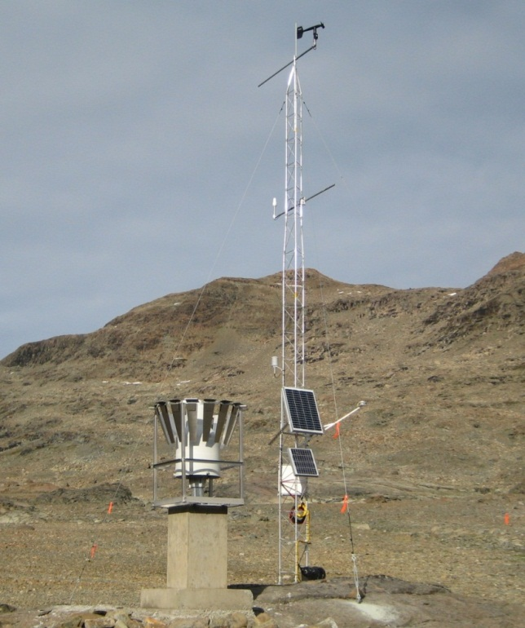
Figure 2. Example Meteorological Station Installation
MET station installation is intended to provide instrumentation that is sturdy enough to work continuously with little maintenance and produce high quality data through a telemetry system.
A Campbell Scientific CR1000 data logger will be used to record data. The archiving interval for all meteorological parameters will be 15 minutes, with a storage capacity to log up to two (2) years of data before filling the memory. The meteorological station is powered by a 12 Vdc 8 amp-hour battery and a 20-watt solar panel complete with charge regulator.
To protect the stations from wildlife intrusion and to discourage any potential vandalism the stations will be protected by fencing as appropriate.

Satellite or Radio Telemetry Communications System
Real-time data will be downloaded from the data logger using satellite transmission or radio telemetry hardware. This will enable study staff to download, inspect, and archive the data as well as monitoring station operational parameters for signs of problems without visiting the site. The communication will ensure that problems, if occur, are resolved promptly so that minimal data will be lost between the service periods.
      - Baseline Water Quality Monitoring
Overview
The purpose of the baseline water quality studies is to assess the effects of the proposed project operations on water quality in the Susitna River basin and to identify and develop protection, mitigation, and enhancement measures that can be implemented to minimize these effects.
Baseline water quality collection can be broken into two components, In-Situ Water Quality Sampling and General Water Quality Sampling. In-Situ Water Quality Sampling consists of on-site measurements of physical parameters at fixed locations using field equipment. General water quality sampling will consist of periodic grab samples that will be sent to an off-site laboratory for analyses. In general these samples represent water quality components that cannot be easily measured in-situ, such as metals concentrations, nitrates, etc.
Data collection will be at the locations in bold on Table 1. This proposed spacing follows accepted practice when segmenting large river systems for development of Total Maximum Daily Load (TMDL) water quality models. Sampling during winter months will be focused on locations where flow data is currently collected (or historically collected by the USGS) and will be used in water quality modeling (WQ-S3).
Monitoring Parameters
Water quality samples will be analyzed for the following parameters:
Table 3 Parameters for water quality monitoring and laboratory analysis.
Parameter | Analysis Method | Sample Holding Times
Water Quality Monitoring Parameter
In-Situ Measurements
Dissolved Oxygen (DO) | Water Quality Meter |  | Not Applicable
pH | Water Quality Meter |  | Not Applicable
Water Temperature | Water Quality Meter |  | Not Applicable
Specific Conductance | Water Quality Meter |  | Not Applicable
Turbidity | Water Quality Meter |  | Not Applicable
Redox Potential | Water Quality Meter |  | Not Applicable
Laboratory Analysis Parameter
General Parameters
Hardness | EPA - 130.2 |  | 180 days
Nitrate/Nitrite | EPA - 353.2 |  | 48 hours
Ammonia as N | EPA - 350.1 |  | 28 days
Total Kjeldahl Nitrogen | EPA - 351.2 |  | 28 days
Total Phosphorus | EPA - 365.3 |  | 28 days
Ortho-phosphate | EPA - 365.3 |  | 48 hours
Chlorophyll a | SM 10300 |  | 28 days
Total Dissolved Solids | EPA - 160.1 |  | 7 days
Total Suspended Solids | EPA - 160.2 |  | 7 days
Turbidity | EPA - 180.1 |  | 48 hours
TOC | EPA - 415.1 |  | 28 days
DOC | EPA – 415.1 |  | 28 days
Fecal Coliform | EPA 1604 |  | 30 hours
Metals – (Water) Dissolved and Total
Aluminum | EPA – 6010B/6020A |  | 48 hours
Arsenic | EPA – 6010B/6020A |  | 48 hours
Cadmium | EPA – 6010B/6020A |  | 48 hours
Chromium (III & IV) | EPA – 6010B/6020A |  | 48 hours
Copper | EPA – 6010B/6020A |  | 48 hours
Iron | EPA – 6010B/6020A |  | 48 hours
Lead | EPA – 6010B/6020A |  | 48 hours
Mercury | EPA – 7470A |  | 48 hours
Nickel | EPA – 6010B/6020A |  | 48 hours
Selenium | EPA – 6010B/6020A |  | 48 hours
Zinc | EPA – 6010B/6020A |  | 48 hours
Metals –Sediment (Total)
Aluminum | EPA - 200.7 |  | 180 days
Arsenic | EPA - 200.7 |  | 180 days
Cadmium | EPA - 200.7 |  | 180 days
Copper | EPA - 200.7 |  | 180 days
Iron | EPA - 200.7 |  | 180 days
Lead | EPA - 200.7 |  | 180 days
Mercury | EPA – 245.5 / 7470A |  | 28 days
Zinc | EPA - 200.7 |  | 180 days
Metals – Fish Tissue (Use EPA Sampling Method 1669)
Total Mercury | EPA – 1631 |  | 7 days
Methylmercury | EPA – 1631 |  | 7 days
Arsenic | EPA - 1632, Revision A |  | 7 days
Cadmium | EPA - 1632 |  | 7 days
Selenium | EPA - 1632 |  | 7 days
Water quality samples will be labeled with the date and time that the sample is collected and preserved/filtered (as appropriate), then stored and delivered to a State-certified water quality laboratory for analyses in accordance with maximum holding periods. A chain-of-custody record will be maintained with the samples at all times.
The State-certified laboratory will report (electronically and in hard copy) each chemical parameter analyzed with the laboratory method detection limit, reporting limit, and practical quantification limit. The laboratory will attempt to attain reporting detection limits that are at or below the applicable regulatory criteria and will provide all laboratory QA/QC documentation
Water quality data will be summarized in a report with appropriate graphics and tables with respect to Alaska State Water Quality Standards and any applicable federal standards.
Sampling Protocol
Water quality grab samples will be collected during each site visit in a representative portion of the stream channel/water body, using methods consistent with Alaska State and EPA protocols for sampling ambient water and trace metal water quality criteria.
Mainstem areas of the river not immediately influenced by a tributary will be characterized with a single grab sample. Areas of the mainstem with a nearby tributary will be characterized collecting an upstream and tributary sample. All samples will be collected from a well-mixed portion of the river/tributary.
These samples will be collected on approximately a monthly basis (4 samples from June to September) and used for calibrating the same model framework used for predicting temperature. The period for collecting surface water samples will begin at ice break-up and extend to beginning of ice formation on the river. Limited winter sampling (once in December, and again in March) will be conducted where existing or historic USGS sites are located.
Water samples will be collected using appropriate sample container upstream of any agitated water that has been mixed either by a boat or walking.
Variation of water quality in a river cross-section is often significant and is most likely to occur because of incomplete mixing of upstream tributary inflows, point-source discharges, or variations in velocity and channel geometry. It is possible that a flow-integrated sampling technique employed by USGS known as the equal width increment/equal transit rate (EWI) method (Edwards and Glysson, 1988; Ward and Harr, 1990) will be used. In this method, an isokinetic sampling device (a sampler that allows water to enter without changing its velocity relative to the stream) is lowered and raised at a uniform transit rate through equally-spaced verticals in the river cross-section. This can be done either by wading with hand-held samplers or from a boat using a winch mounted sampler, depending on river stage and flow conditions. The number of verticals employed will differ between sites depending on the site specific conditions.
Additional details of the sampling methods will be provided in the Sampling and Analyses Plan (SAP) and the Quality Assurance Project Plan (QAPP) for this study.
In-Situ Water Quality Sampling. During each site visit, in-situ measurements of dissolved oxygen, pH, specific conductance, redox potential, turbidity, and water temperature will be made. A Hanna Instruments HI 98703 Portable Turbidity Meter will be used to measure turbidity, while a Hydrolab® datasonde (MS5) will be used to measure the remaining field parameters during each site visit. Continuous turbidity measurement may be conducted with the Hydrolab datasonde at select locations (e.g., former/current USGS sites where turbidity data is available from the 1980s) and operate during summer and winter conditions. The following list of former and current USGS mainstem Susitna River monitoring sites will be considered for continuous turbidity monitoring: Susitna Station, Sunshine, Gold Creek, Tsusena Creek, and near Cantwell. These locations have historic and current flow data that will be used in water quality modeling (WQ-S3) of effects on turbidity from project operations. Standard techniques for pre- and post-sampling calibration of in-situ instrumentation will be used to ensure quality of data generation and follows accepted practice. If calibration failure is observed during a site visit field data will be corrected according to equipment manufacturer’s instructions.
General Water Quality Sampling. Sampling will avoid eddies, pools, and deadwater. Sampling will avoid unnecessary collection of sediments in water samples, and touching the inside or lip of the sample container. Samples will be delivered to EPA approved laboratories within the holding time frame. Each batch of samples will have a separate completed chain of custody sheet. A field duplicate will be collected for 10% (i.e., 1 for every 10 water grab samples) collected for laboratory analysis. Laboratory quality control samples including duplicate, spiked, and blank samples will be prepared and processed by the analytical laboratory
Quality Assurance/Quality Control (QA/QC) samples included field duplicates, matrix spikes, duplicate matrix spikes, and rinsate blanks for non-dedicated field sampling equipment. The results of the analyses will be used in data validation to determine the quality, bias and usability of the data generated.
Sample numbers will be recorded on field data sheets immediately after collection. Samples intended for the laboratory will be stored in coolers and kept under the custody of the field team at all times. Samples will be shipped to the laboratory in coolers with ice and cooled to approximately 4° C. Chain of custody records and other sampling documentation were kept in sealed plastic bags (Ziploc) and taped inside the lid of the coolers prior to shipment. A temperature blank accompanied each cooler shipped. Packaging, marking, labeling, and shipping of samples will be in compliance with all regulations promulgated by the U. S. Department of Transportation in the Code of Federal Regulations, 49 CFR 171-177.
The procedures used for collection of water quality samples will follow protocols from Alaska Department of Environmental Conservation (ADEC) and the U.S. Environmental Protection Agency Region 10 (Pacific Northwest). Water samples will be analyzed by a laboratory accredited by the ADEC or recognized under the national accreditation program (NELAP; National Environmental Laboratory Accreditation Program).
Additional details of the sampling procedures and laboratory protocols will be included in the SAP and QAPP.
      - Sediment samples for mercury/metals in the reservoir area
This study was designed to gather specific information on the distribution of Susitna sediment contaminants of concern in potential source areas. In general, all sediment samples will be taken from sheltered backwater areas, downstream of islands, and in similar riverine locations in which water currents are slowed, favoring accumulation of finer sediment along the channel bottom. Samples will be analyzed for Total Metals, including aluminum, arsenic, cadmium, chromium, copper, iron, lead, mercury, nickel, selenium, and zinc. In addition, sediment size and total organic carbon (TOC) will be included to evaluate whether these parameters are predictors for elevated metal concentrations. Samples will be collected just below and above the proposed dam site. Additional samples will be collected near the mouth of tributaries near the proposed dam site, including Fog, Deadman, Watana, Tsusena, Kosina, Jay, Goose Creeks, and the Oshetna River. The purpose of this sampling will be to determine where metals, if found in the water or sediment, originate in the drainage. Toxics modeling may be conducted to address potential for bioavailability in resident aquatic life and results from examination of pathways/toxicological models. Comparison of bioaccumulation of metals in tissue analysis with results from sediment samples will inform on potential for transfer mechanisms between source and fate.
Most of the contaminants of interest are typically associated with fine sediments, rather than with coarse-grained sandy sediment or rocky substrates. Therefore, the goal of the sampling will be to obtain sediments with at least 5% fines (i.e., particle size <63 μm, or passing through a #230 sieve). At some locations, however, larger-sized sediment may be all that are available.
The sediment samples will be collected using an Ekman dredge or a modified Van Veen grab sampler. Sampling devices will be deployed from a boat. Samples may also be collected by wading into shallow near shore areas. To the extent possible, samples will consist of the top 15-cm of sediment. Comparison of results from the Susitna drainage will be made with other studies for Blue Lake, Eklutna Lake, and Bradley Lake when similar data are available and where physical settings are comparable.
      - Document baseline metals levels in fish tissue and compare to state criteria
Two screening level studies will be conducted. The first will be for methyl mercury in sport fish. Methyl mercury bioaccumulates, and the highest concentrations are typically in the muscle tissue of adult predatory fish. Final determination of tissue type(s) for analysis will be coordinated with Alaska Department of Environmental Conservation Division of Environmental Health and guidance on fish tissue sampling. Target fish species in the vicinity of Susitna-Watana Reservoir will be Dolly Varden, Arctic grayling, whitefish species, burbot and resident rainbow trout. Filets will be sampled from seven (7) adult individuals from each species, if possible. Body size targeted for collection will represent the non-anadromous phase of each species life cycle (e.g., Dolly Vardon; 90mm – 125mm total length to represent the resident portion of the life cycle). Collection times for fish samples will occur in late August and early September. Filet samples will be analyzed for methyl and total mercury.
Samples will also be collected of the Burbot livers, and analyzed for mercury, methymercury, arsenic, cadmium, and selenium.
Field procedures will be consistent with those outlined in applicable Alaska State and/or EPA sampling protocols (USEPA 2000). Clean nylon nets and polyethylene-gloves will be used during fish tissue collection. The species, fork length, and weight of each fish will be recorded. Fish will be placed in Teflon sheets and into zipper-closure bags and placed immediately on ice for delivery to the analytical laboratory. Fish samples will be submitted to a State-certified analytical laboratory for individual fish muscle tissue analysis. Results will be reported with respect to applicable Alaska State and federal standards.
1.2.6.6 Conduct a pilot thermal imaging assessment of a portion of the Susitna River

Thermal imagery of a portion of the Susitna River (e.g., 10 miles of the Middle River) will be collected in the 2012 season. Data from the thermal imagery will be ground-truthed and the applicability and resolution of the data will be determined in terms of identifying water temperatures and thermal refugia/upwelling. In coordination with the In-stream Flow and fish studies, a determination will be made as to whether additional thermal imaging data will be applicable and whether or not additional thermal imaging will be collected during the 2013 field season to characterize river temperature conditions.

If the pilot study is successful, then a description of thermal refugia throughout the project area can be mapped using aerial imagery calibrated with on-the-ground verification. The verification data will be collected at the same time as the aerial imagery (or nearly the same time) using the established continuous temperature monitoring network and additional grab sample temperature readings where there may be gaps, such as in select sloughs. The following elements are important considerations for data collection, specifications for data quality, and strategy for relating digital imagery and actual river surface water temperatures.

Radiant Temperature
Remotely sensed thermal images allow for spatially distributed measurements of radiant temperatures in the river. Radiant temperature measurements are made only on the surface layer of the water (top 10cm). Temperature readings can vary depending on the amount of suspended sediment in the water and the turbidity of the water.

Spatial Resolution
The key to good data quality is determining the pixel size of the TIR sensor and how that relates to the near-bank environment. Best practice is 3 pure-water pixels (ensures that the digital image represented by any 3 contiguous pixels identifies water versus land). Very fine resolution (0.2 – 1m) imagery is best used to determine ground water springs and cold-water seeps. Larger pixels can be useful for determining characteristic patterns of latitude and longitude thermal variation in riverine landscapes.

Calibrating Temperature
Water temps change during the day, therefore collection should be measured near the same time daily and when water temp is most stable (early afternoon). Validation sampling site selections are determined where there is channel accessibility and where there are not known influences of tributaries, or seeps in the area. Hand-held ground imaging radiometers can provide validation as long as the precision is at least as good as that expected from airborne TIR measurements. Availability of historical satellite imagery for thermal analysis will be investigated. Historical thermal imagery may enables exploration of potential trends in water temperature both spatially and temporally.

1.2.6.7. Groundwater Quality in Selected Habitats

The purpose will be to characterize the water quality differences between a set of key productive aquatic habitat types (3-5 sites) and a set of non-productive habitat types (3-5) sites that are related to the absence or presence of groundwater upwelling to improve the understanding of the water-quality differences and related groundwater/surface-water processes.

At selected in-stream flow, fish population, and riparian study sites collect basic water chemistry (temperature, DO, conductivity, pH, turbidity, redox potential) that define habitat conditions. This data will be used to characterize groundwater and surface water interactions.

  - Level of Effort and Cost
The cost and level of effort will be refined during the final study design. At this time, it is anticipated to be as follows:
- Planning ($100k)
- Monitoring ($900k)
- Workgroup Involvement ($200K)
- Data Analysis ($300k)
- Reporting ($200k)

  - Literature Cited
ADEC. 2005. Water Quality Assessment and Monitoring Program. Alaska Department of Environmental Conservation: Division of Water. Juneau, Alaska. 58p.
AEA. 2011. Pre-Application Document: Susitna-Watana Hydroelectric Project FERC Project No. 14241. Volume I of II. Alaska Energy Authority, Anchorage, AK. 395p.
Edwards, T.K., and D.G. Glysson. 1988. Field methods for measurement of fluvial sediment. U.S. Geological Survey Open-File Report 86-531, 118 p.
Ward, J.C., and C.A. Harr (eds.). 1990. Methods for collection and processing of surface-water and bed-material samples for physical and chemical analyses. U.S. Geological Survey Open-File Report 90-140, 71 p.
URS. 2011. AEA Susitna Water Quality and Sediment Transport Data Gap Analysis Report. Prepared by Tetra Tech, URS, and Arctic Hydrologic Consultants. Anchorage, Alaska. 62p.+Appendixes.
USEPA. 2000. Guidance for Assessing Chemical Contaminant Data for use in Fish Advisories: Volume 1 Fish Sampling and Analysis, 3rd Edition. EPA-823-B-00-007. United States Environmental Protection Agency, Office of Water. Washington ,D.C. 485p.

